**REPORT 27 JUNE**

**Meta-process and Process description**

The figure 1 illustrates our data integration meta-process. Three general steps compose it: query management, SLA management and query rewriting. Each step in the meta-process includes different actions used to define our data integration process (Figure 2).

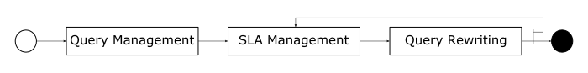

Figure - Meta-process

The query management step includes activities concerning the query specification and preferences definition according to the user. The SLA management includes a set of activities associated to the SLA manipulation. Such as: search for previous integration SLA, create a new integration SLA, reuse an integration SLA, SLA enforcement, update an integration SLA and store an integration SLA. The query rewriting includes activities concerning the rewriting process according to the user requirements and the characteristics, and constraints of each entity in our data integration metamodel. Such as: search for data producers, filter data producers according to the SLAs, generate integration plan, execute integration plan, retrieve data, integrate results and deliver results.

The data integration process described in the figure 2 uses the activities defined by the meta-process. Firstly, a user specifies his/her query according to his/her needs. In addition, he/she also defines a set of preferences and associate them to the query. Given a query and user preferences, a search for previous integration SLAs (that are associated to a previous integration) that matches with the actual query and preferences is proceeded. If a match is found, the information about this previous integration is reused and a new integration SLA is created using this information. If no match is found, a new integration SLA is created without any previous information. Then, a set of query rewriting activities are performed to generate the execution plan. Results are computed and the integration SLA is updated and stored to be used in a next integration request. The query rewriting activities sub-process include (i) searching for data producers that can produce an answer to the query; (ii) filtering data producers according to the user preferences, to the consumer SLAs and to the producer SLAs. This means it is necessary to verify if the data producer is out of resources or not, and if the consumer has enough resources to process the data provided by the producer; (iii) generating the execution plan according to the SLAs; (iv) enforcing the SLAs associated to the involved services; and (v) executing the integration plan. Computing results sub-process retrieves data, integrates results and deliver them.

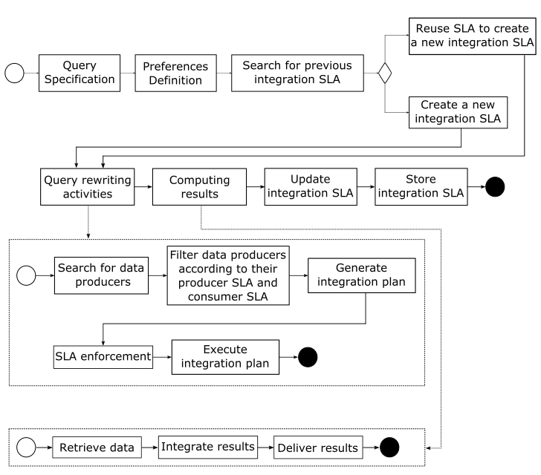

Figure - Process